**Monday** (Robo Truck)

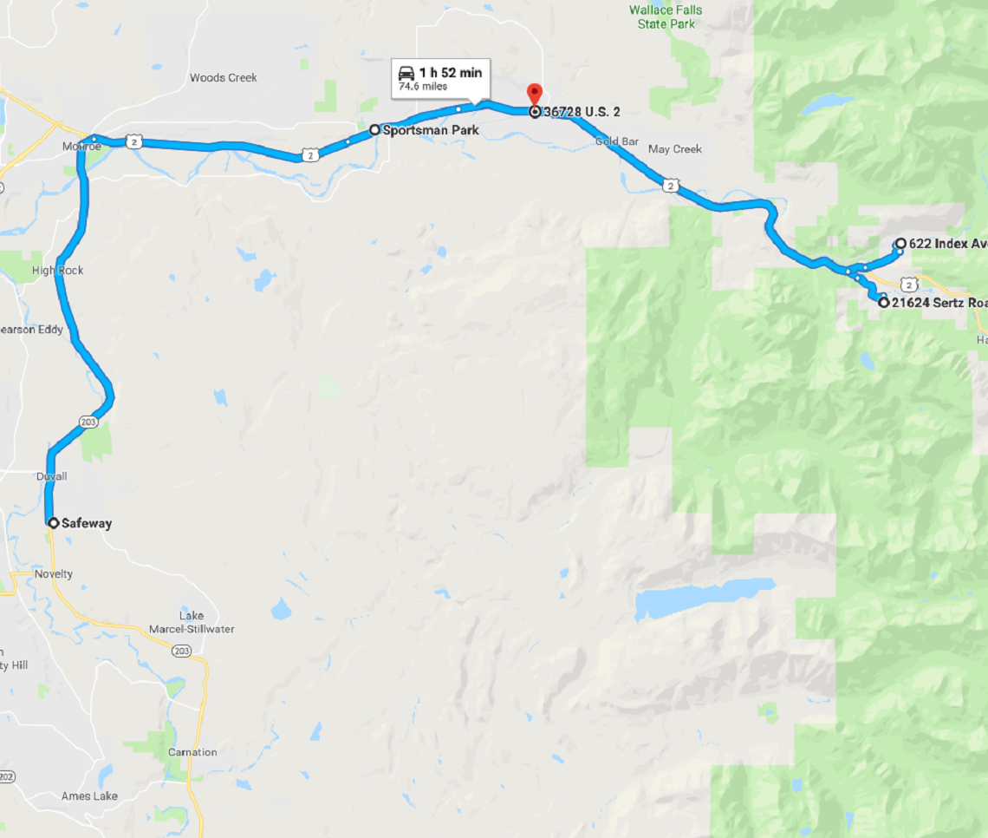

Notes: